EXPT NO 7.1 Monitoring HTTP and HTTPS packets using Wireshark

Objective:
2. To capture and analyze HTTPS packets using Wireshark and study the role of TLS encryption in securing web traffic and protecting transmitted data.
Software Requirements
- Wireshark
- Web Browser (Google Chrome/Mozilla Firefox)
- Internet Connection
Websites Used
HTTPS Website
https://arms.sse.saveetha.com/
Theory
HTTPS (Hypertext Transfer Protocol Secure)
HTTPS is the secure version of HTTP. It uses TLS (Transport Layer Security) to encrypt data exchanged between the client and the server. The encryption protects sensitive information such as usernames and passwords from unauthorized access.
Procedure:
Part B: Monitoring HTTPS Traffic
Step 1: Start a new Wireshark capture session.
Step 2: Open a web browser and access:
https://arms.sse.saveetha.com/
Step 3: Log in using authorized credentials.

Step 4: Stop packet capture.
Step 5: Apply the filter: tls
Step 6: Observe:
- Client Hello
- Server Hello
- TLS Handshake
- Certificate Exchange
- Encrypted Application Data
Step 7: Verify that login credentials are not visible.
Output:
Objective 2: HTTPS Traffic Analysis
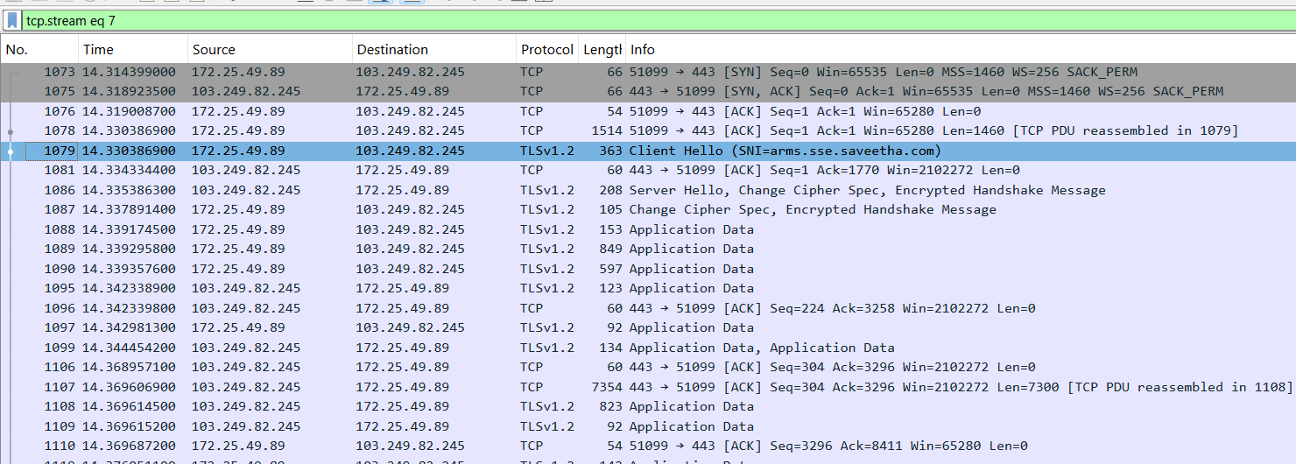
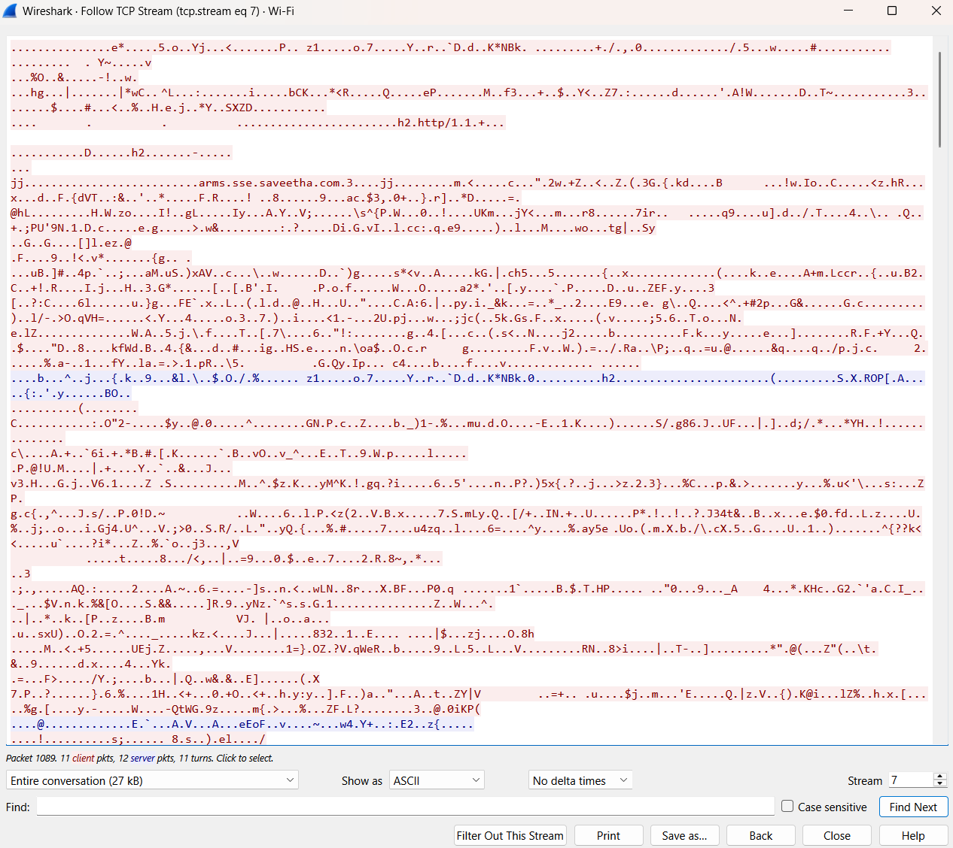

Username entered | Password entered | Username detected | Password detected
vishnu | 12345 | enrypted | encrypted

Result:
Objective 2: HTTPS Traffic Analysis
HTTPS traffic was successfully captured and analyzed using Wireshark. The TLS handshake and encrypted application data were observed, while sensitive information such as usernames and passwords remained protected and unreadable. This demonstrated the effectiveness of TLS encryption in securing web communications.

